**JMeter script recording**

Create a Test Plan and save it

Click on the Save button

Select the workspace to save files.

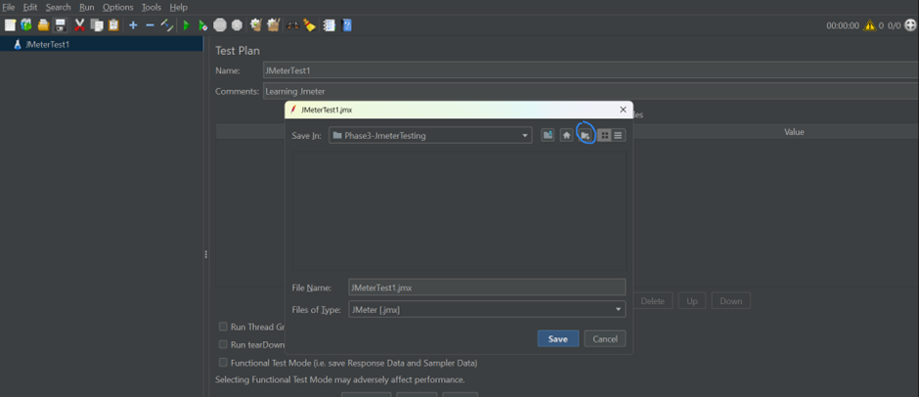

Add a thread group to a Test plan

Right click of Test Plan -Go to Add-go to Thread -Click on Thread Group

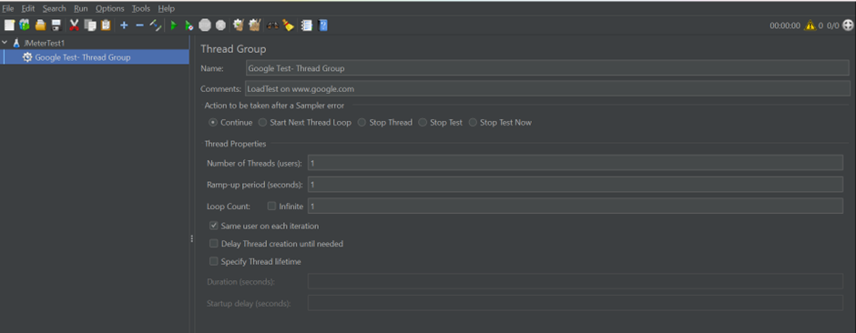

To record script:

To do this, first we have to set up proxy server on our laptop,Go to laptop search box -go to proxy settings

Set off for automatic detect settings

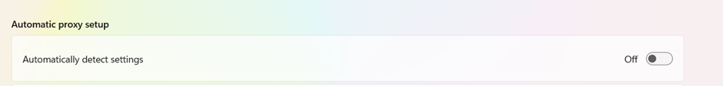

We will go to manual proxy setup -> click on set up -click on use a proxy server -> click on Save button.

Now go to JMeter and add the recording elements:

Right click on Test Plan - Add - Non test elements -Https Test Script Recorder

Add the recording controller to the thread group

Right click on thread group add logic controllers Recording controller

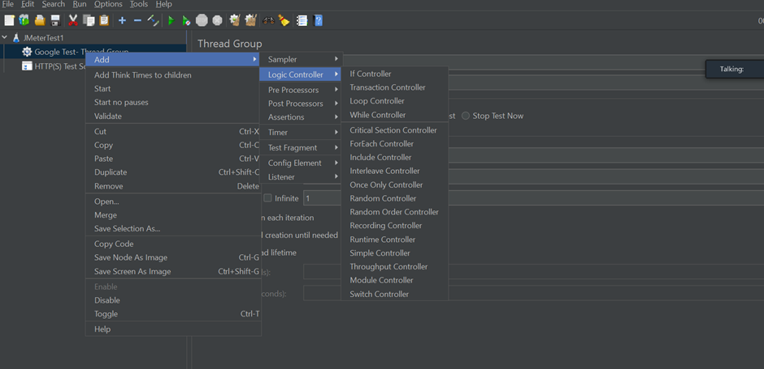

Select the recording controller in HTTP Tets Script recorder.

Click on Start button -click ok on the certificate adding request

Side one box will open and take the url and paste it in the browser.

Click on advance→ click on proceed to link.

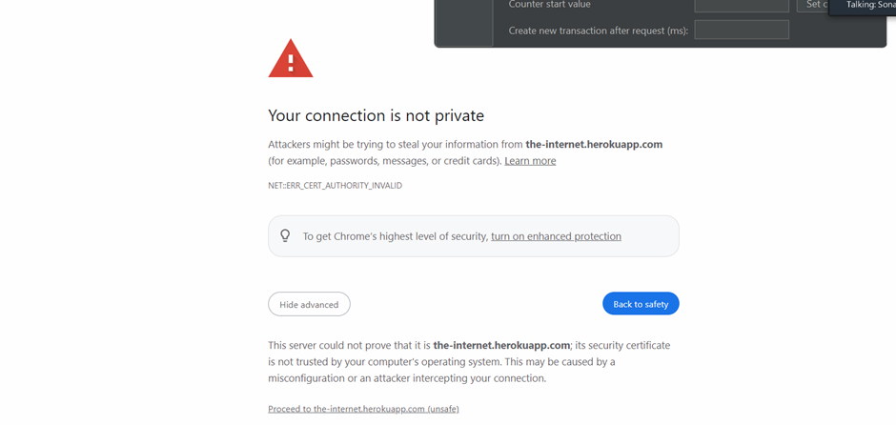

Record transaction to loginto the application.

After click on login button, create anew transaction as logout

Click on logout button.

Click on stop button on transaction control.

Now under recording controller, you will see the recored scripts, Right click and remove the request which have server name or ip.

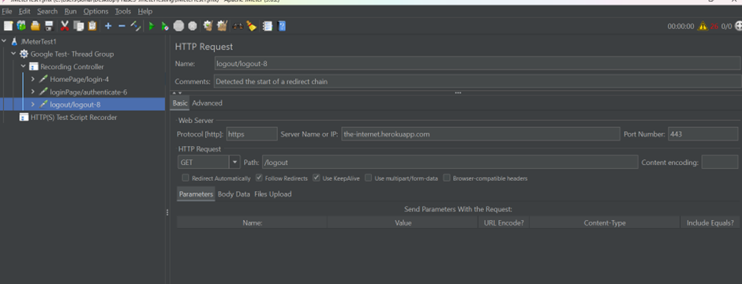

Now move the recorded transactions in Simple Controller,s imple controller is just like a folder that holds your test scripts .

Add a Listeners to the thread group

ThreadGroup-Add -> Listners-View results tree, to see the result

